Question 1.
Refer to the following 2 by 2 table and answer the questions shown:

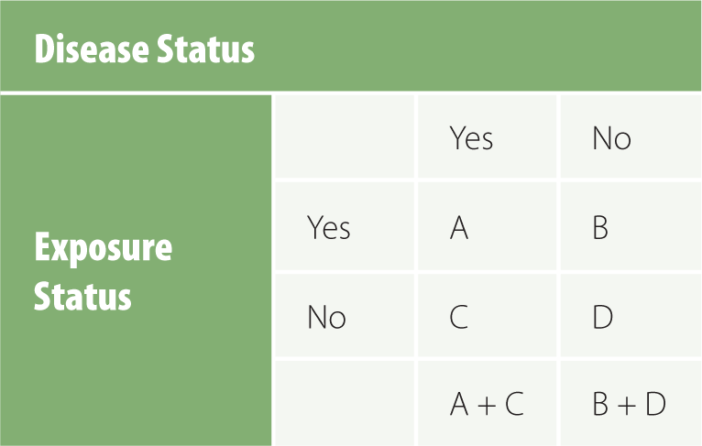
A = 21; B = 9; C = 3; B + D = 11

- A+C=?
- D=?
- OR=?
- Given the results of your calculations and assuming the results are statistically significant, would you say that the exposure is a risk factor or protective factor for the disease?

Question 2.
Calculate the OR for the following 2 by 2 table:
Outcome
Yes No
Factor
Yes 37 68
No 24 121
(OR=Odds ratio)

Question 3.
Table X
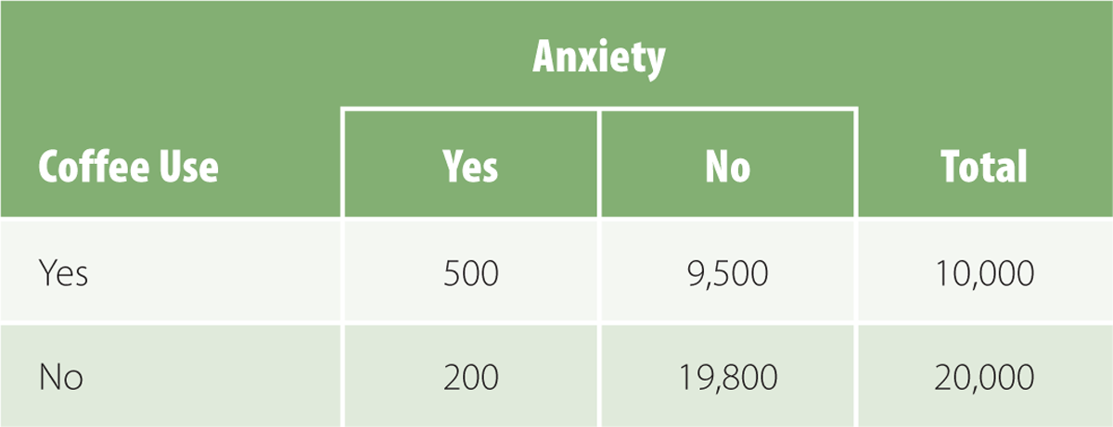

A cohort study was conducted to investigate the association between coffee consumption and anxiety in a population-based sample of adults. The data are presented table X.
- What is the RR of anxiety associated with coffee use?
- Calculate the risk (rate) difference.
- What is the etiologic fraction?
- Determine the population etiologic fraction.
RR= Relative risk

